- Repository created by Vignesh in github.
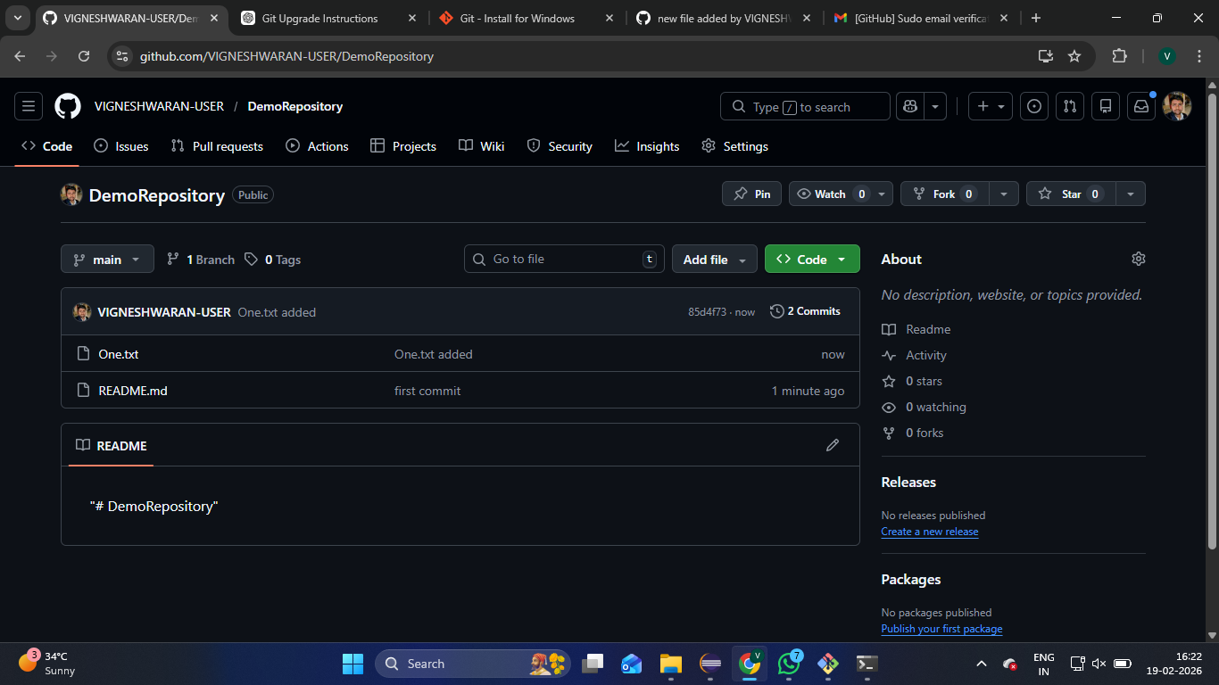

- Vetri and Subathra added as collaborators.
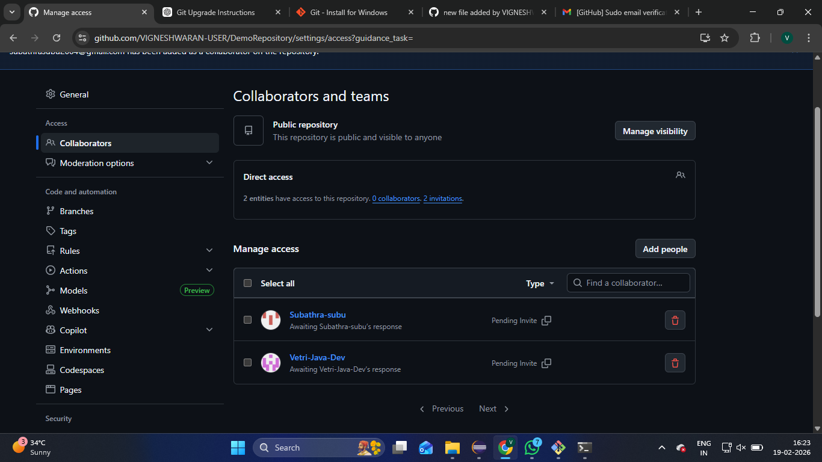

- The repo is cloned by the collaborators
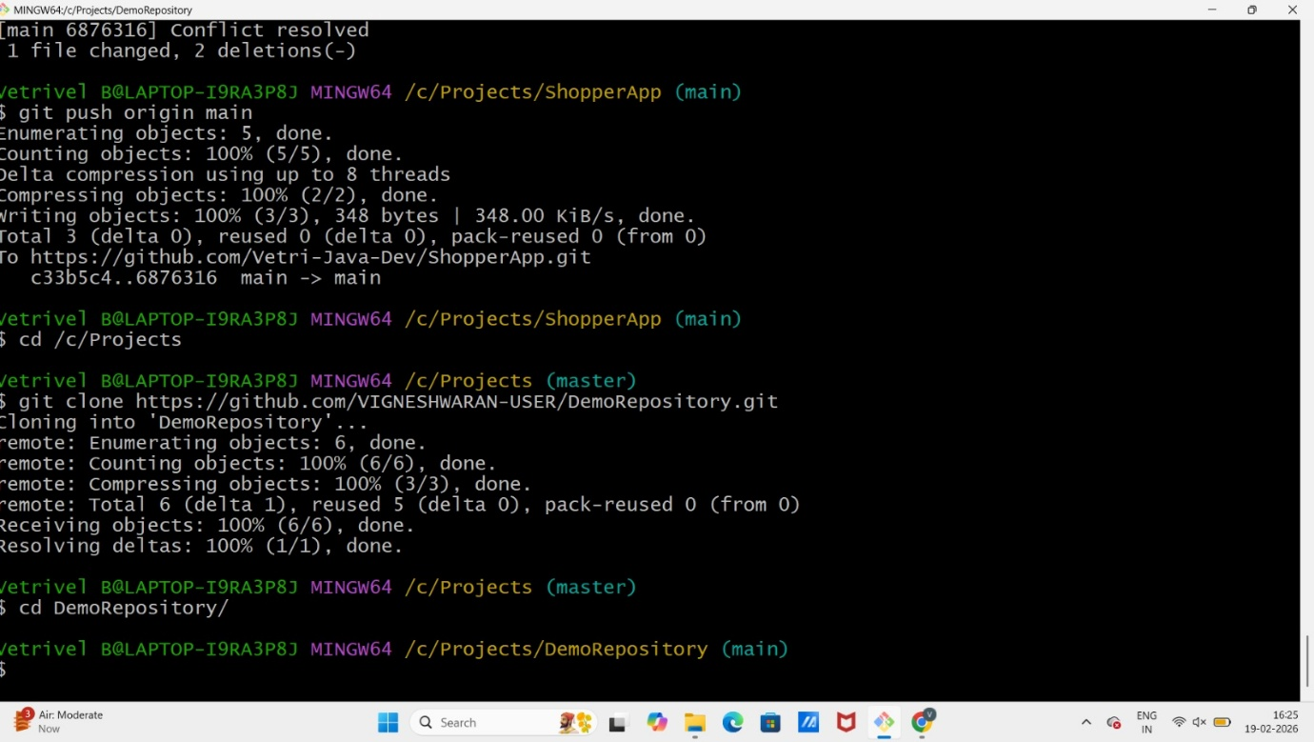

- Editing the One.txt file and created a branch name as Vetri.
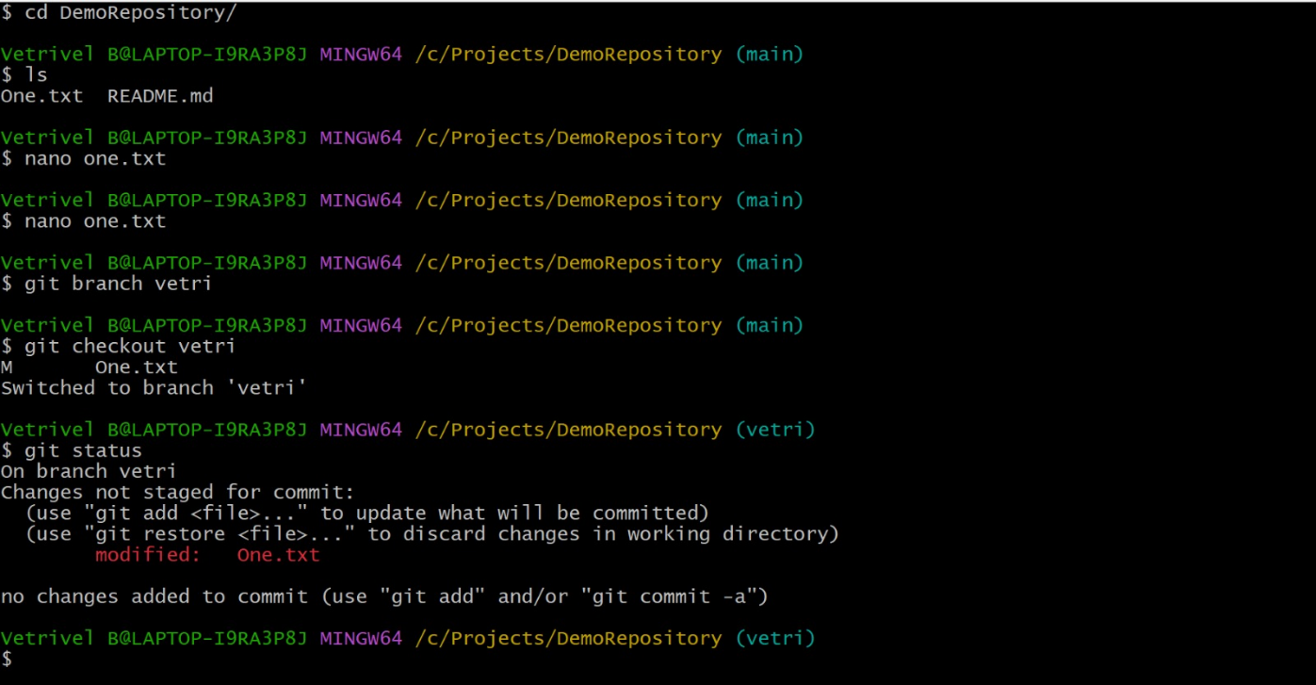

- Adding one line in the file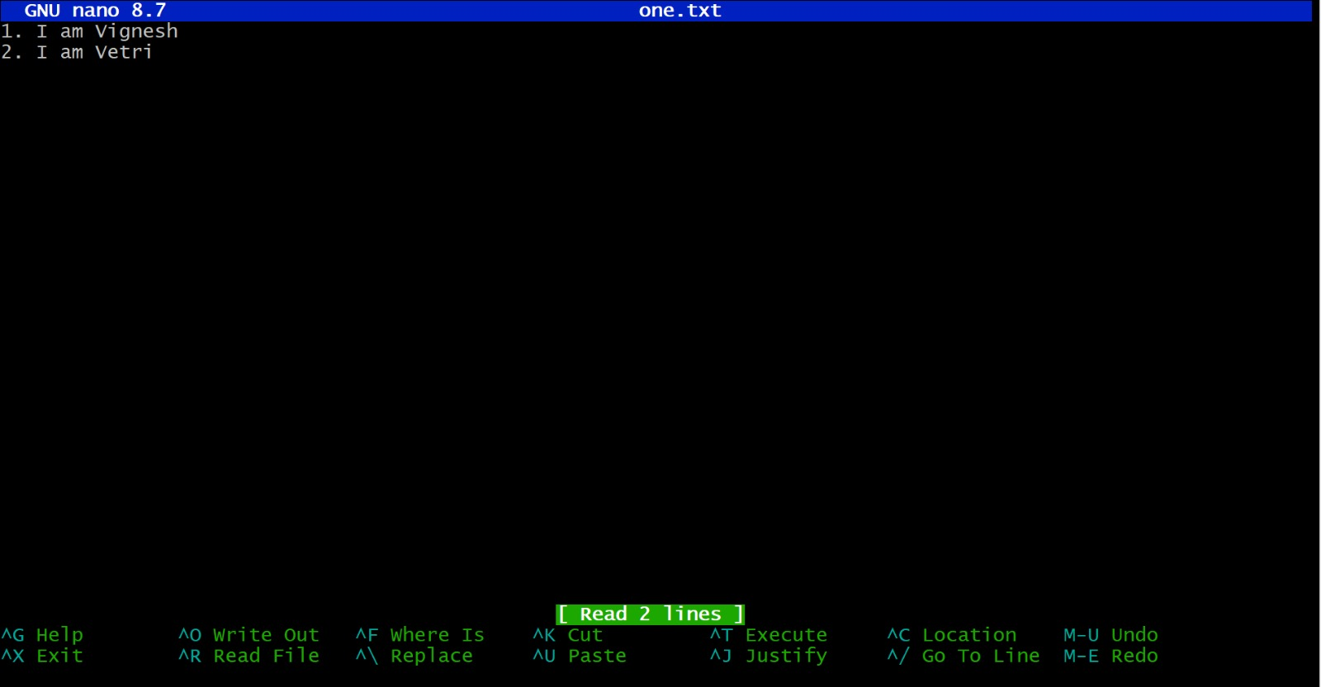

- Pushing the changes in his branch called Vetri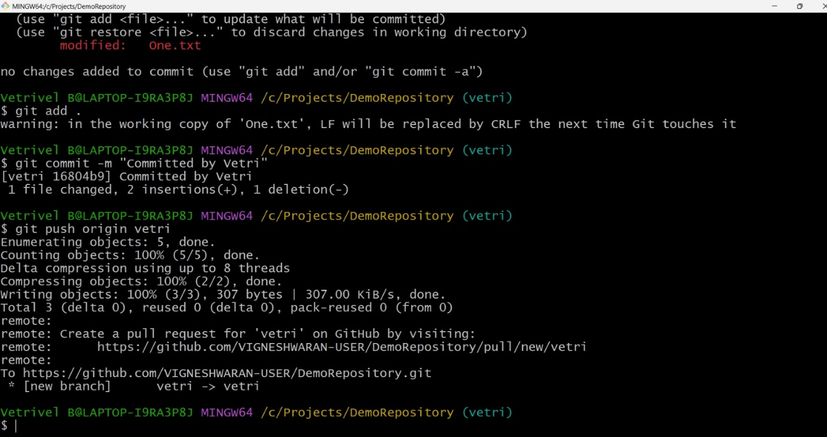

- Simultaneously Subathra editing the One.txt file and created a branch name as Subathra.
- Adding one line in the file
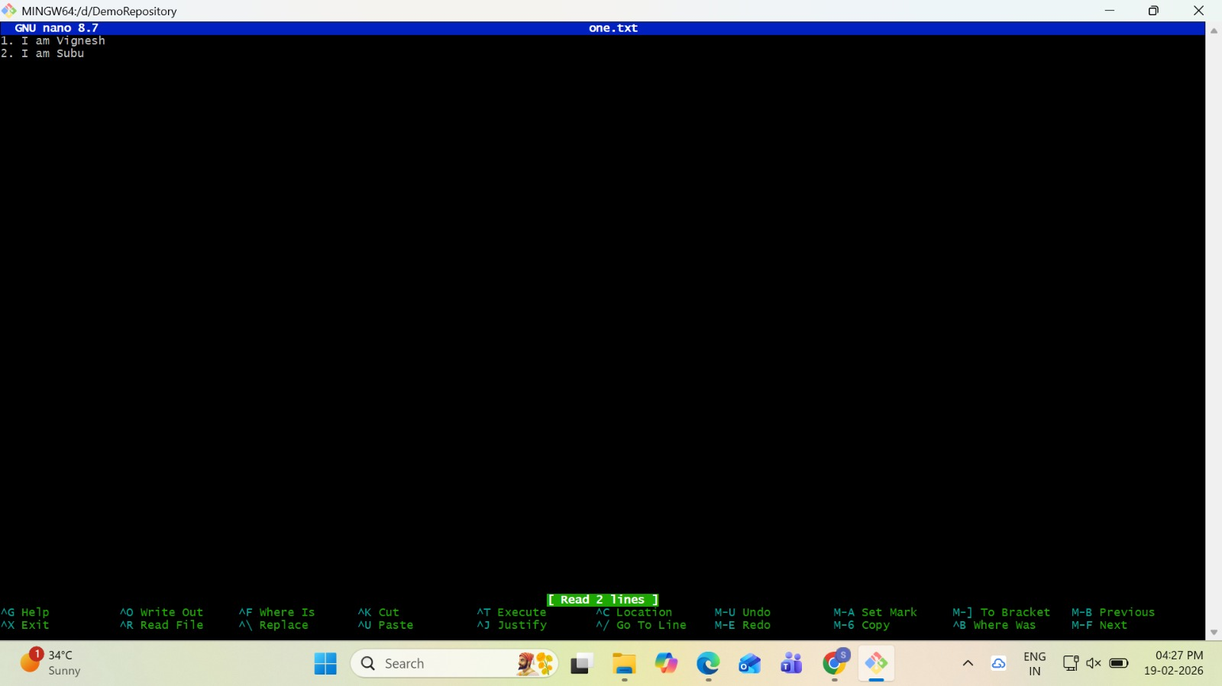
- Pushing the changes in her branch called Subathra.
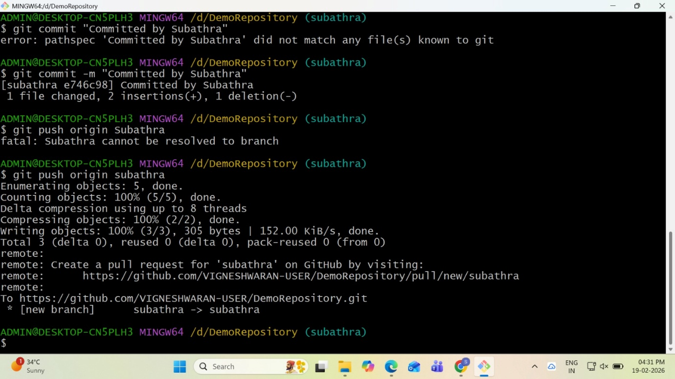

- Then vetri merge and push in main branch
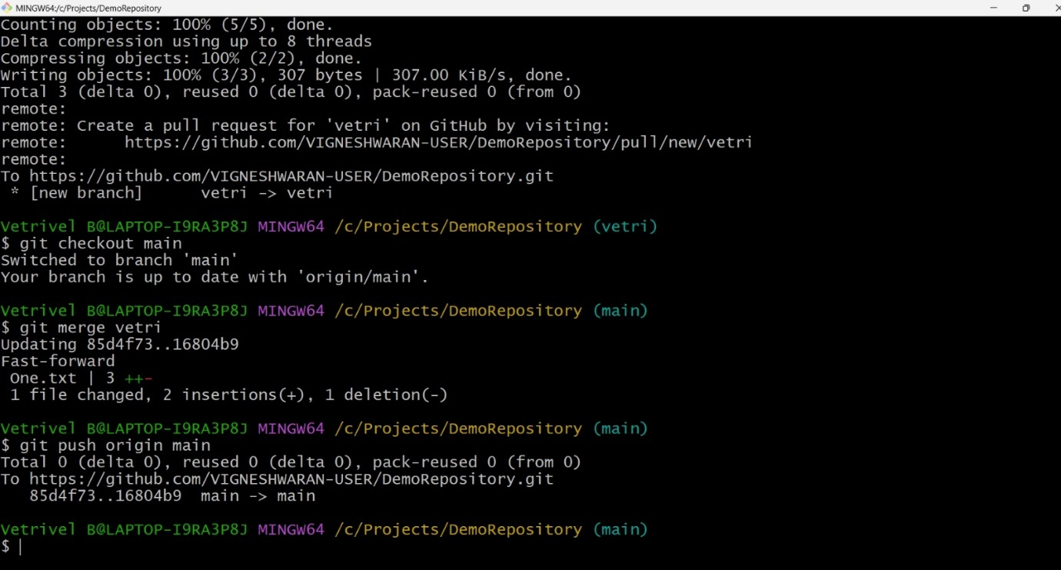

- Repository after merging vetri’s branch (no - conflicts)
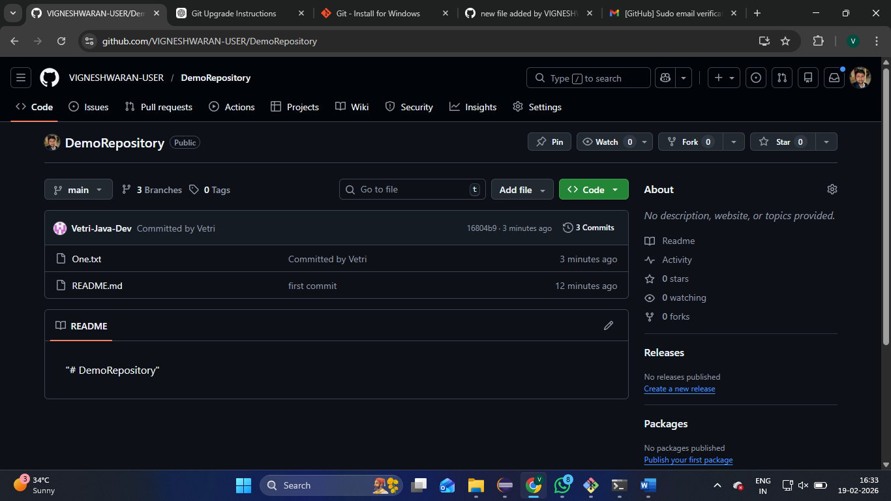

- Now Subathra trying to merge unaware of pulling latest main
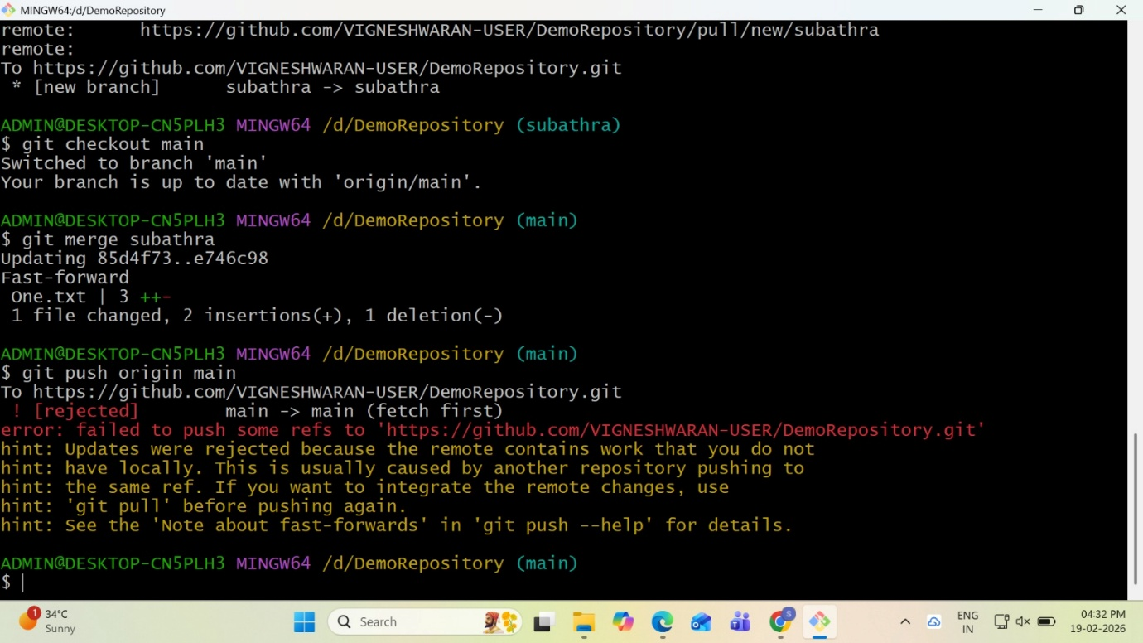
- Then she pull the code and the conflict occurred because of edited the same file
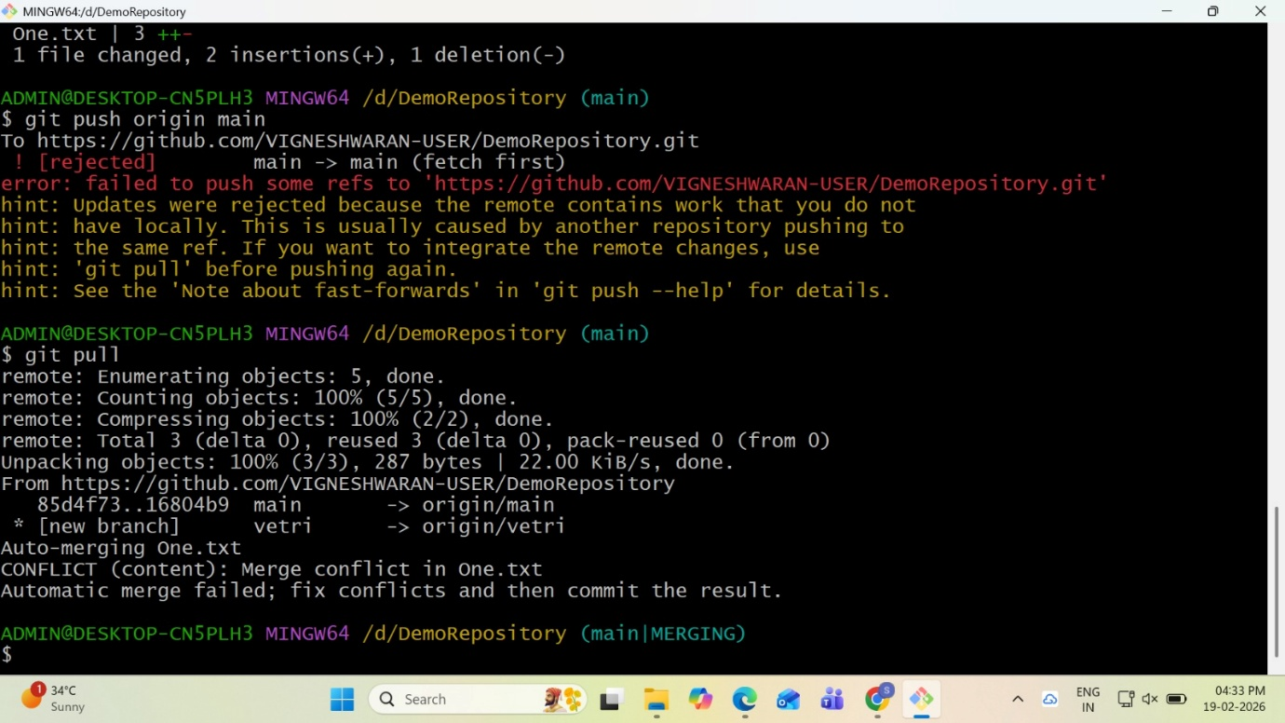

- Then she checked the git status and found that both modified the One.txt file.
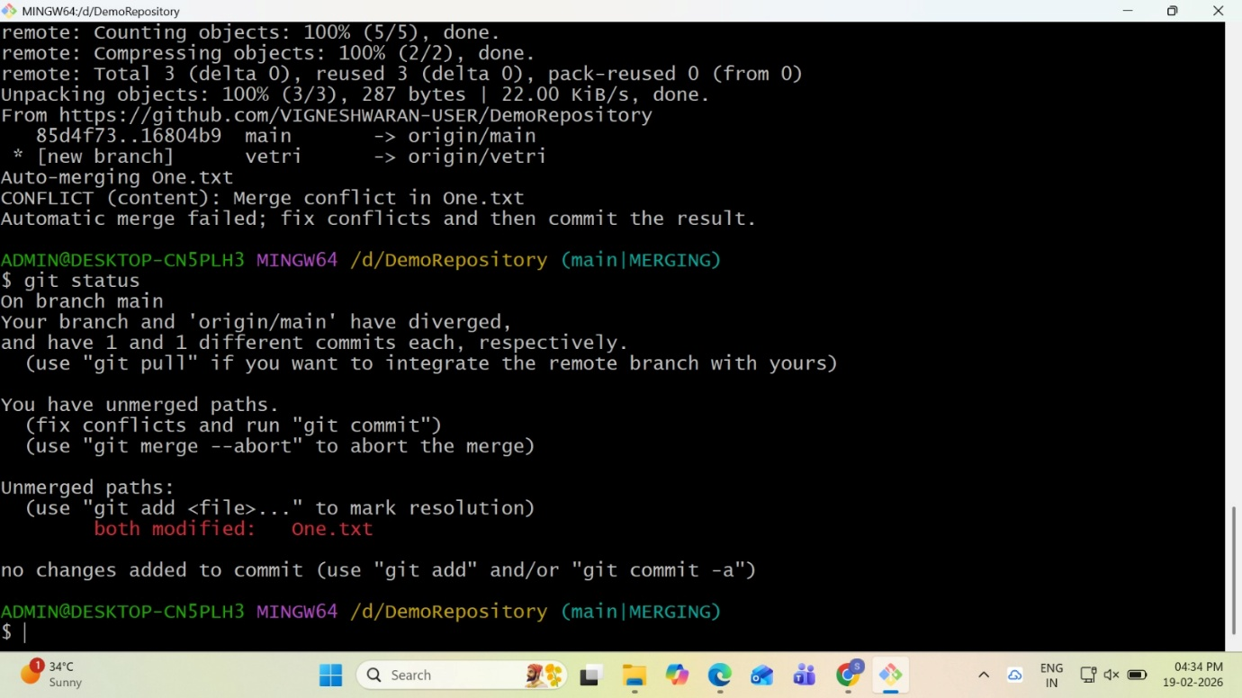

- Then she opened the file and see the conflict
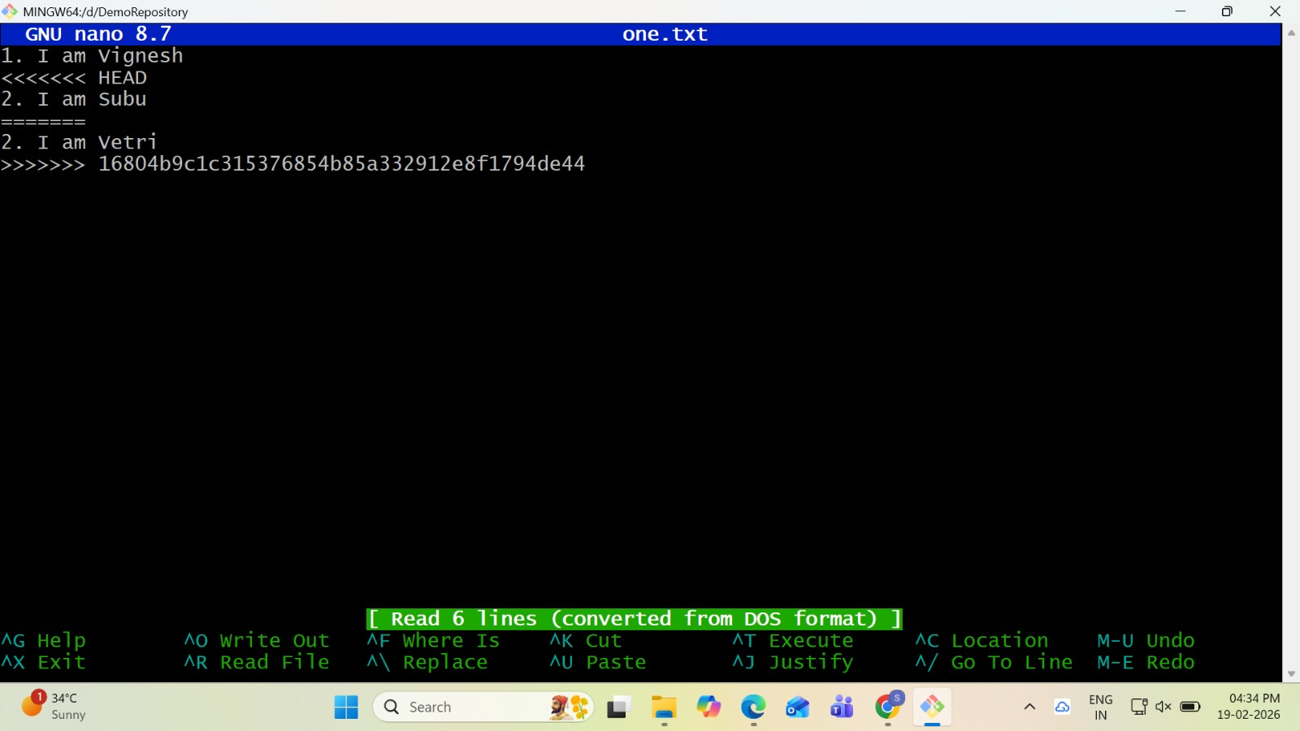

- She resolved the conflict and saved the file.
- Then she pushed the file into repository.
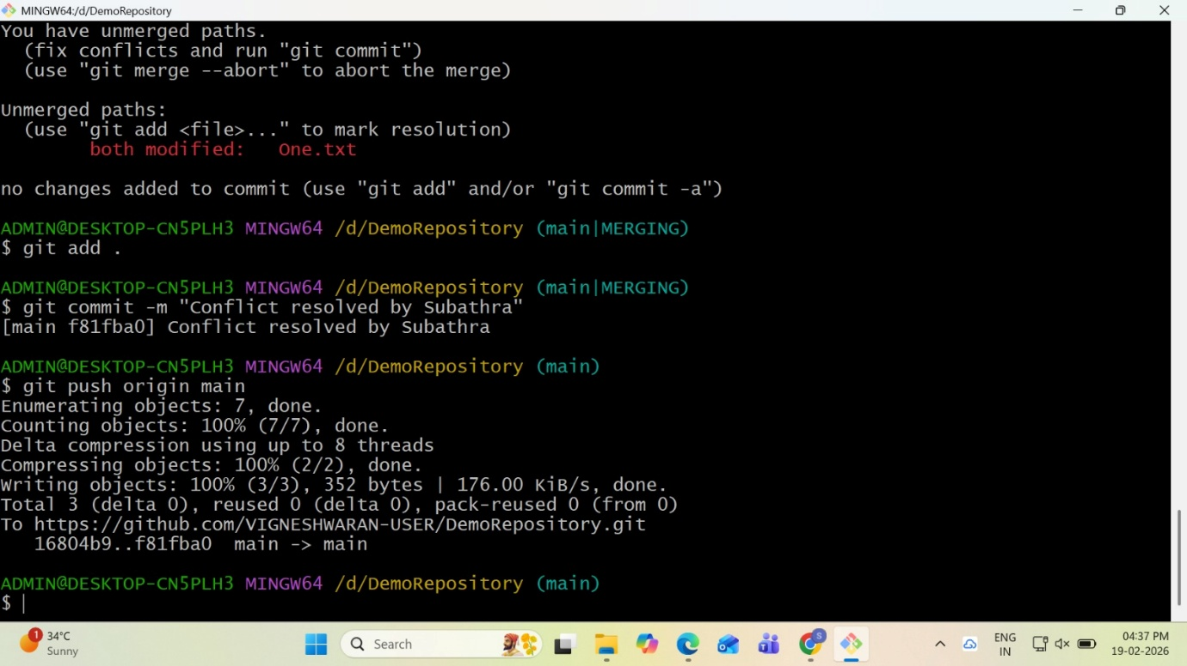

- Repo after resolving conflict.
sss